  宙  時  魂 | Asia-Oceania Federation Of Medical Physics  www.afomp.org

2007 AFOMP Annual Council Meeting

Minute of Meeting

Date : August 23rd (Thu), 2007
Time : 16:30 – 18:00
Venue : Lianjiang Hall, Huangshan International Hotel

AFOMP Annual Council Meeting, 2006, HuangShan, China

Minutes of Meeting

Venue : Lianjiang Hall, Huangshan International Hotel
Time : 16:30-18:00, 23rd August 2007
Present :
Kiyonari Inamura, President (Voting Delegate of JSMP, Japan)
Barry Allen, IOMP President, Past President (Voting Delegate of ACPSEM, Australia)
Kwan-Hoong Ng, Vice President (Voting Delegate of Malaysia)
Tae Suk Suh, Secretary General (Voting Delegate of KSMP, Korea)
Anchali Krisanachinda, Treasurer (Voting Delegate of Thailand)
Kin-Yin Cheung, ETC Chair (Voting Delegate of KSMP, Hong-Kong)
Surat Vinijsorn, Voting Delegate of Thailand
Sung Kyu Kim, Voting Delegate of KSMP, Korea
Hee Joong Kim, Korea
Hong-Jin Toh, Voting Delegate of Singapore
Yimin Hu, Organizing Chair, Voting Delegate of China

Seungjong Oh, Webmaster of AFOMP

- Agenda: The meeting agenda is given in Appendix 1
- President’s Report: Kiyonari Inamura (Japan) presented the President’s report (Appendix 2). Agreed by B Allen (Australia) and second by K H Ng (Malaysia).
- Discuss Asia-regional meeting and agreed to organize Task Group with president of regional meeting for more discussion
- Treasurer’s Report: A Krisanachinda (Thailand) presented the Treasurer’s report (Appendix 3) and the report was endorsed by Council Members. Agreed by K Inamura (Japan) and second by K Y Cheung (Hong-Kong).
- USD 4400, fund brought forward from 2005/2006 in item description, were clearly explained: 1) USD 4000 from donation of KSMP (WC2006), 2) USD 400 from KAO.
- Secretary General’s Report: T.S. Suh (Korea) presented the Secretary General’s report (Appendix 4). Agreed by K Y Cheung (Hong Kong) and second by Anchali (Thailand)
- Original idea of new logo was from Barry Allen with K Y Cheung and K H Ng
- Education and Training Committee Report: K Y Cheung (Hong Kong) presented ETC report (Appendix 5). Agreed by K Inamura (Japan) and second by K H Ng (Malaysia)
- Professional Development Committee Report: K H Ng (Malaysia) presented PDC report (Appendix 6). Agreed by T S Suh (Korea) and second by K Y Cheung (Hong-Kong)
- Kwan recommended to see EFOMP document in webpage
- AFOMP definition of medical physicist was included in PDC report
- Science Committee Report: SC Report was not presented due to his absence in council meeting (Appendix 7).
- Commercial Fund Committee Report: Barry Allen (Australia) presented the CFC Report (Appendix 8) Agreed by T S Suh (Korea) and second by K Y Cheung (Hong Kong).
- Countries profiles were introduced by Barry Allen (Appendix 9)
- Barry Allen, present IOMP President and former president of AFOMP explained his effort to establish constant activity of HTTTG specially with reference to the Mekong Delta region of Vietnam (Appendix 10).
- Barry Allen raised issue of membership dues for AFOMP and explained the need of AFOMP dues (Appendix 11)
- AFOMP decided to notice this issue and obtain the opinion from AFOMP members, finally vote for AFOMP dues
- AFOMP decided to publish AFOMP newsletter
- AFOMP agreed to choose T S Suh as an editor of AFOMP newsletter, and Suh asked Barry Allen and K Y Cheung to be reviewers of AFOMP newsletter
- Issue of Mongolia was presented by K Y Cheung (Appendix 12)
- Barry Allen and Anchali Krisanachinda introduced the possibility of their foundation of medical physics society in Vietnam (Appendix 13).
- Report of BSS meeting in Vienna was presented by K Y Cheung (Appendix 14)
- SEACOMP 2007 in Manila in November was announced by Anchali, the president of SEAFOMP.
- Ho Chi Minh city, Vietnam was determined as the host city of 8th ACOMP and endorsed by AFOMP members (Appendix 15).
- AOB
- AOCMP 2010 was little discussed. Some candidates of hosting country (India, Mongolia, etc) were mentioned a little. However, AFOMP concluded that the hosting country of AOCMP 2010 would be determined based on the regulation of call for EOI.

This meeting was adjourned at 18:00 pm

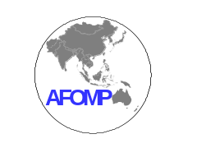 宙 時 魂 | Asia Oceania Federation of Organisations for Medical Physics  www.afomp.org

2007 AFOMP Annual Council Meeting

Date : August 23th (Thu.), 2007
Time : 16:30-18:00
Venue : Huangshan International Hotel

Agenda

Attendance

Minutes of the 2006 Council Meeting

1. President's report, Treasurer's report and Secretary General's report
2. Report from Committee Chairmen: ETC, PDC, SC, and CFC
3. Definition of medical physicist (led by Kwan)
4. Country profiles for MP (led by Barry)
5. HTTTG (Health Technology and Training Task Group) (led by Barry)
6. Issue of membership dues for AFOMP membership (led by Barry)
7. News letter (led by Barry)
8. Issue of Mongolia (led by KY)
9. Issue of Vietnam Society of Medical Physicist (led by Anchali)
10. Report of BSS meeting in Vienna (led by KY)
11. SEACOM2007 in Manila in November (led by Agnette P. Peralta)
12. 8th AOCMP in Vietnam (led by Barry)
宙 時 魂 | Asia Oceania Federation of Organisations for Medical Physics  www.afomp.org
President’s report

AFOMP President Kiyonari Inamura

This is the first report for me as AFOMP President. Everything is on the way to be completed, but being discussed and carried out with enthusiasm by every member of AFOMP EXCOM. Most members including myself have paid attention and made effort to solve financial difficulties, namely raising fund problem. We had bitter experiences, but the cause of unsuccessful contract is gradually being foreseen.

1. 7th AOCMP is being held by our colleague Professor Yi Min Hoo in Huangshan from 23rd to 27th, August, 2007 in conjunction with Annual Meeting of Chinese Society of Medical Physics of which President is Professor Yi Min Hoo.

2. Financial difficulties, namely raising fund problem
Our activities such as carrying out training courses of medical physics and cultivate organizations of medical physics in developing countries have been limited by lack of the budgetary resource. We have to prepare enterprises very concrete document to stimulate proper donations by getting them what benefit by when and how in addition to present rule of merit.

2-1. Training course of digital radiography in Bangkok by the sponsorship of Fuji was programmed and just before being conducted in last fall, but it was not realized.
2-2. Possibility of corporate membership with Toshiba is still being sought.
2-3. Elekta and IBA have interests to be Corporate members.
2-4. Financial aid from IOMP was proposed, and the proposal was submitted to IOMP.
2-5. IOMP adopted the same membership dues formula with that of IOMP herself, and news letters publication by AFOMP is being discussed.

3. Definition of qualified medical physicist is still in the midst of some of difficulty. We are recognizing that this problem is not simply the wording of sentences of definition. For an instance, very severe contradiction or confrontation problems against radiological technologists is reveling up. Government of a developing country in the field of medical physics such as Japan does not recognize significance of training medical physicists according to definition of qualified medical physicists which is solely described. They do understand the definition by writing but do not move to spend governmental budget to train medical physicists in addition to radiological technologists which have hundreds times of population of medical physicists. Much time of myself was spent to solve the problems so far, I have to confess.

Sooner or later this question will be coming up in the process of foundation of medical physics organizations and raising funds from enterprises in developing countries such as Burney, Mongolia and Vietnam.

One of the causes of financial difficulties may be recognition by enterprises. What is the clear difference of contribution to medical practice compared with that by medical doctors and/or technologists, we have to present to enterprises.

Any way we have to fix our own definition thinking over the transient situation of medical physics in our region.

4. Country profiles are requested to be collected to grasp situation of medical physics in developing countries in our region.

5. Issue of Mongolia
KY Cheung visited Mongolia and looked for the possibility to be one of our members. We have got his report and opened to discussion now.

6. Issue of Vietnam Society of Medical Physics
Barry J Allen and Anchali Krisanachinda visited Vietnam. Possibility of their foundation of medical physics society in Vietnam has now matured.

7. Health Technology and Training Task Group (HTTTG)
Barry J Allen, present IOMP President and former president of AFOMP is devoting his effort to establish constant activity of HTTTG. We AFOMP EXCOM decided to support HTTTG, with concentrating but without diffusing our effort. It will be discussed in AFOMP EXCOM and AFOMP Council Meeting in Huangshan.

8. Report of BSS meeting in Vienna (led by KY)
AFOMP sent KY Cheung to attend BSS ( Basic Safety Standard) held in Vienna at the end of July, 2007. His report has been distributed. We have to recognize new tendency and prepare to get leadership for realizing new regime.

9. SEACOM 2007 in Manila in November
Our colleague Agnette P. Peralta announced SEACOM 2007 to be held in November 2007 in Manila.

10. BIIJ (Biomedical Imaging and Intervention Journal) is selected as the second official journal of AFOMP.

11. 8th AOCMP is sought to be held in Vietnam next year.

12. Logo of Chinese letters 宙、時 and 魂 are added to official letter head. They mean cosmos, time and spirit.

宙 時 魂 | Asia Oceania Federation of Organisations for Medical Physics  www.afomp.org
TREASURER’S ANNUAL REPORT
7th AOCMP 23-27 August 2007
Huangshan, China

Account of Income and Expenditure for the Year 2006/2007
Item Description | (A)  Expenditure | (B)  Income
Accounting activity* | 1,740 | 0
Balance | -1,740
Fund brought forward from 2005/2006 | US$ 4,400
Balance carried forward to 2006/2007 | US$ 2,660


Anchali Krisanachinda
Treasurer
23 August 2007

*Note: Travel expense to participate IAEA BSS Meeting,Vienna Austria in July 2007

宙 時 魂 | Asia Oceania Federation of Organisations for Medical Physics  www.afomp.org
Secretary General’s report

1. Report in 6th AOCMP in conjunction with WC2006
The 6th AOCMP in conjunction with WC2006 was held successfully in Seoul in 2006.
The Congress Summary was reported by Dr. N Z Xie and KY Cheung in the Medical Physics World (Vol. 22, No. 2). (Annex 1)
Summary of 6th AOCMP will be presented at 7th AOCMP.

2. Updating the office bearers
The new AFOMP office bearers were updated in the APESM Journal on January 2007.

3. New AFOMP letter head with the addition of new logo
Dr. Inamura and Dr. Kwan designed new AFOMP letter head with three Chinese characters (宙、時 and 魂).

4. Medical Physics free recipients
By the request of Dr. Hendee William, Dr. KH Ng recommended some possible recipients of free electronic subscriptions to Medical Physics.

5. UNDP project in Korea
The main aim of this project was to provide selected resource persons with opportunities for training in Korea to share technology and experiences about QA in radiotherapy. There was a fundamental & intermediate training on offer in 2007. This training, which focused on clinical field experiences, was held in three medical centers in Korea. In accordance with the project, KFDA invited four medical physicists and two radiation oncologist to participate in the 2007 training.
(Annex 2. UNDP Project, Annex 3. Summary of training)

6. Related Conferences
1. Announce the 7th AOCMP & 13th CSMP in China
2. Advertise the International EMF Conference 2007 in Malaysia
3. Advertise the IEEE Nuclear Science Symposium and Medical Imaging Conference 2007 in Hawaii
4. Endorse the Preclinical Imaging Tentative Programme UMRIS 2007
5. Announce the UNDP Workshop in Korea (Annex 4)
6. Advertise International Stereotactic Radiosurgery Society (ISRS) which will be held in Seoul in 2008

7. AFOMP Membership
Vietnam was interested in the membership to AFOMP. AFOMP send all related documentation to Hoa Nguyen, and still wait for applying for the membership to AFOMP.

8. Sponsor SC&J
SC&J interested to become corporate member of AFOMP and wanted to be the Bronze Cooperative Member.

9. Current statues of AFOMP website
1. Adding a sponsor link: Elekta in August
2. Inserting a web counter in August
3. Uploaded the photos of Treasurer and SC chair
4. Problems
- Bulletin board is not used at all
(There are only 6 articles after 6th AOCMP)
- Some information is still missing
(Scientific committee members, Committee roles of PDC and SC)

Submitted to AFOMP EXCOM & Council Meetings, 2007
ANNEX 1 Medical Physics World (Vol. 22, No. 2)
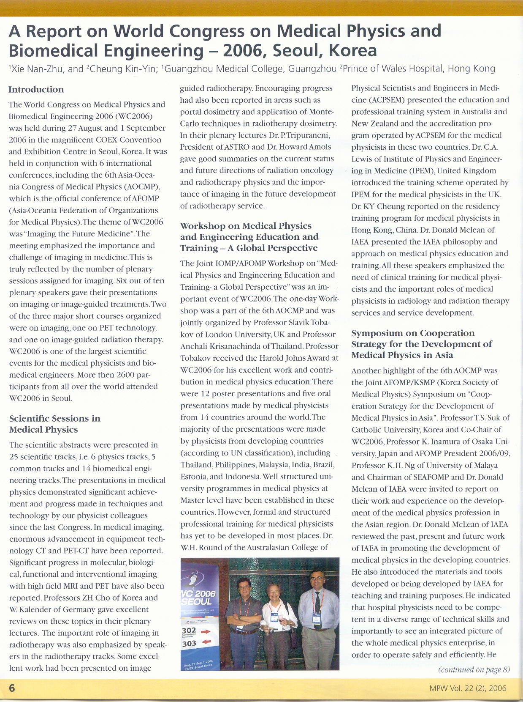
ANNEX 2 UNDP Project 1/2
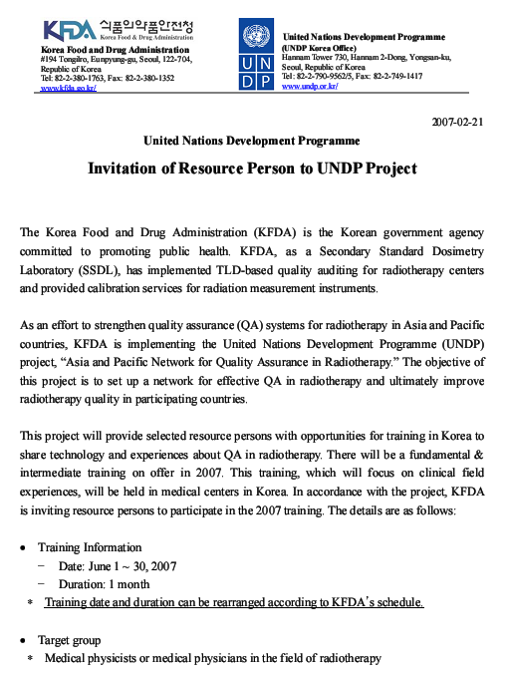
UNDP Project 2/2
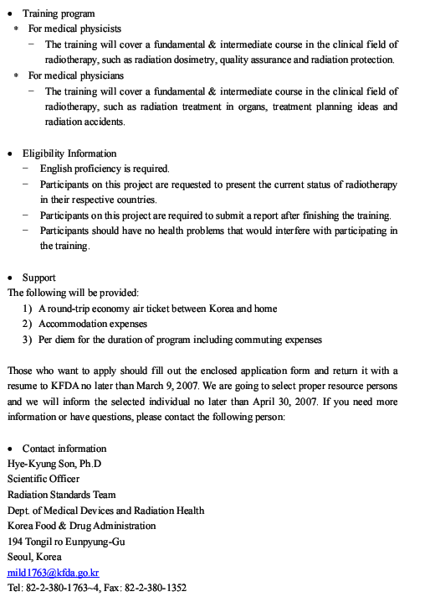
ANNEX 3 Summary of training
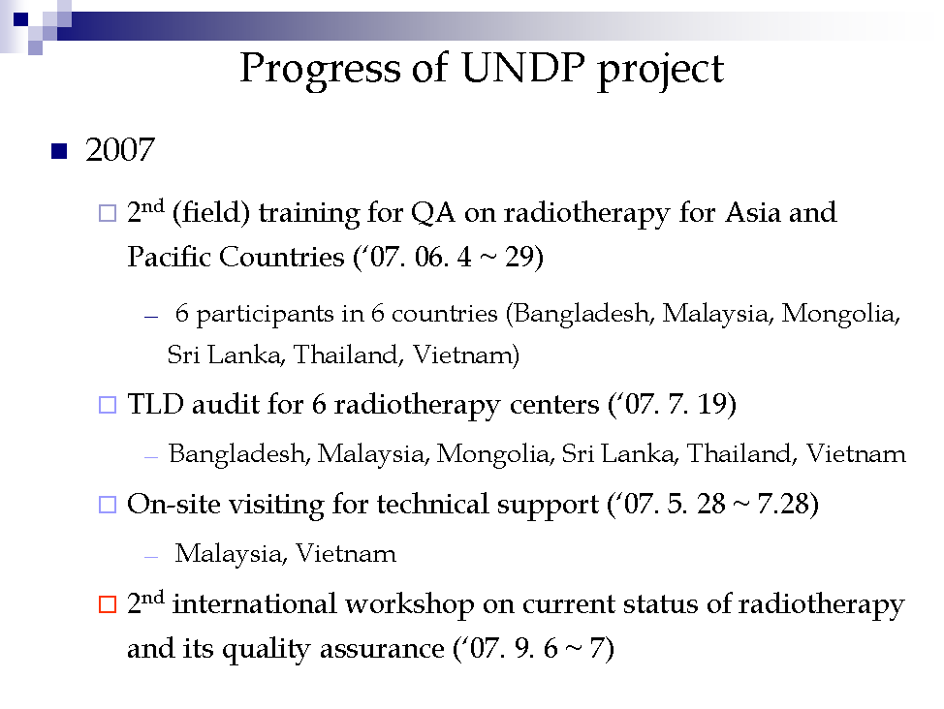
ANNEX 4 UNDP Workshop
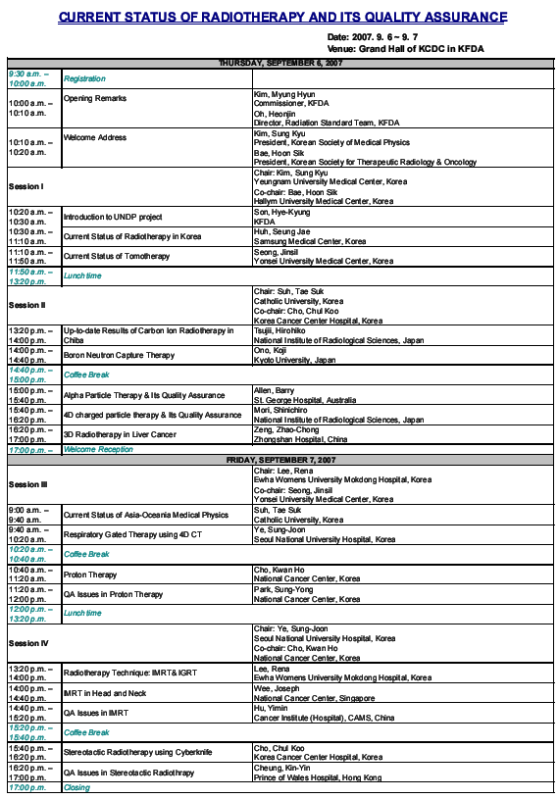
宙 時 魂 | Asia Oceania Federation of Organisations for Medical Physics  www.afomp.org

Medical Physics Education and Training in AFOMP
KY Cheung, Chairman, Education & Training Committee, AFOMP

AFOMP established an Education and Training Committee (ETC) in 2001 to look into issues related to education and training of medical physicists (MP) in AFOMP. One of the initiatives taken by AFOMP ETC was the establishment of a co-operative working relationship with IAEA on training of medical physicist in the region. In an IAEA Regional Co-operative Agreement (RCA) Project meeting held Hong Kong in 2002, the follow problems were identified in most AFOMP member countries:
- No agreed definition on roles and responsibilities of MPs
- No agreed definition on qualification of MPs
- Lack of information on the number of MPs required
- No agreed standard for the region on minimum and recommended number of MPs
- Lack of information on education and training facilities and level of their programme
- Lack of legal requirements to enforce the implementation of quality and safety standards
- Lack of official recognition (status) of MPs
- Differences in implementation of professional standards
- Lack of expertise (trainers) and equipment

In an attempt to look at some of these issues, a survey was conducted in 2003 by AFOMP aiming to identify the manpower and training needs of its member countries. The result of the survey indicated that at least 1000 medical physicists were required in the region. The survey also indicated that while tertiary education programs in medical physics up to master level had been established in most countries, comprehensive clinical training programs were not available in most countries. Another survey conducted by AFOMP ETC in 2005 aiming to collect views from MPs in member countries on the targets and level of standardized education and training of medical physics in Asia and Oceania region. The information collected in the surveys provided some insights for AFOMP in formulating its strategy on E&T matters.

Two workshops on medical physics education and training were organized jointly by IOMP ETC and AFOMP ETC (one at WC2003 in Sydney and the other in WC2006 in Seoul) to further explore the above issues. Speakers form AFOMP countries, Europe, North America and IAEA were invited to report the situations on E&T in different parts of the world. A symposium on cooperative strategy for the development of medical physics in Asia was also organized jointly by AFOMP and Korean Society of Medical Physics during WC2006. A conclusion that could be drawn from these meetings was much of the above mentioned problems could be resolved if a formal definition on the qualification, roles and responsibilities of MP could be established and officially adopted within AFOMP countries together with the implementation of a well defined education and a formal structured professional training system in medical physics.

The definition of medical physicists and their roles and responsibilities had been discussed within AFOMP since 2003, but consensus has yet to come amongst its member countries on these issues mainly due to differences in standard and conditions of practice of the MPs in these countries. ETC and Professional Development Committee (PDC) of AFOMP will continue to explore possible solutions on such issues.

AFOMP has in the past few years been in active collaboration with IAEA in its RCA project on the development of clinical training programs for MPs in the region. The Organization will continue to support the project especially on matters related to implementation of such training programs, including assistance in identification of trainers and the training needs, accreditation of training centers and assessment and monitoring of the programs. AFOMP will also work with IOMP and other national and international organizations on E&T and professional issues with the objective of improving the standard and conditions of practice of MPs.

Submitted to AFOMP EXCOM & Council Meetings, 2007
宙 時 魂 | Asia Oceania Federation of Organisations for Medical Physics  www.afomp.org
PDC report

宙 時 魂 | Asia Oceania Federation of Organisations for Medical Physics  www.afomp.org
SC report

宙 時 魂 | Asia Oceania Federation of Organisations for Medical Physics  www.afomp.org
Commercial Funding Committee report

BJA emailed all exhibitors at wc2006 in Seoul, and received only 2 replies, both very positive from IBA and Elekta. These companies expressed interest in AOCMP07 and AFOMP. Both companies to rece4ive 12 months free linkage on our web site.

I received email lists for exhibitors at Seoul, sent of a lot of emails and have only a few replies (Elekta, IBA & SC&J).
These should be exploited for AOCMP, China and for corporate sponsors. These companies now have a free link to their website on our website, as promised in my letter.

宙 時 魂 | Asia Oceania Federation of Organisations for Medical Physics  www.afomp.org
Country profiles
For developing countries only, so as to be able to better understand their capabilities and needs.
1 name of society
2 number of members; classes of membership; accreditation
3 Training; university, technical, on the job.
4 population
5 major hospitals in big cities; radiotherapy centres and machines; imaging centres and machines
6 provincial hospitals; as above
7 district hospitals; as above
8 health stations (doctor); equipment x-ray, ultrasound; blood analysis; computer; internet access.
9 health centres (no doctor); as above
10 referrals up the system; transport;

宙 時 魂 | Asia Oceania Federation of Organisations for Medical Physics  www.afomp.org
Health Technology and Training Task Group

1 Recommendations for improved health care in the Mekong Delta, Vietnam

Health Stations

In order to improve the health care for the majority of Vietnamese who live outside the cities, the capability and functions of the Health Stations (HS) need to be increased.

The health care roles and responsibilities need to be clearly defined for the HS, such that cost savings are made by improved local medical services, reducing the referred patient load at higher levels, and reducing disruption of families when patients need to leave the village for treatment elsewhere.

This can be achieved by the provision of basic equipment; eg x-ray, ultrasound and blood analysis, so that the HS can provide a more complete service. With such facilities, telemedicine would further enhance the capabilities of the HS, with training coming down from higher medical levels and images coming up for expert opinion by radiologists.

Breast and cervical examination for early detection of cancer would also reduce costs and allow curative treatment at higher levels.

Vertical Integration of the Health Service

Telemedicine between all health service levels should be introduced, so as to empower each level, reducing costs and disruption of families.

In that most cancer patients are stage 4, palliative treatment is indicated. Provincial hospitals should have this capability to allow treatment to be regional, sparing patients and families from excessive disruption when family support is most important.

The current health structure is ideal for Vietnam. The Health Stations are the foundation stone of the system, and should receive higher priority for funding and equipment. Such actions would generate cost savings at higher levels, and would certainly facilitate access to health management for the majority of families.

2 Formation of Action Groups

Our recent investigation into the health services in the Mekong Delta of Vietnam led to the attached report. This report calls for action on several fronts. We propose to set up Action Groups (AG) within the HTTTG to address each technical aspect. These Action groups would comprise a Chair, who would form the group, with the intent of reviewing commercially available equipment, evaluating whether such equipment is appropriate for the designated task, and if not, developing specifications and proposing new R&D that would satisfy the specifications.

A scoping report is projected by 3 months, the evaluation at 6 months, and proposed R&D specification, if required, by 12 months. Any Intellectual Property arising from such considerations would be the property of individuals concerned. Draft reports authored by the AG will receive an HTTTG report number and be open for comment by HTTTG members. However, the final report will not be altered or reviewed in any way. Such reports will provide the basis for funding requests. The authors may choose to publish their reports as they wish. HTTTG will simply use these reports as independent, expert opinion on which to develop further actions in the way forward.
AGs are needed in the following topics (√ indicates EOI):
1 Telemedicine √
2 X-ray source and imaging √
3 Ultrasound source and imaging √√
4 Basic blood chemistry analysis √
5 Palliative radiotherapy √
6 Pap smear testing -
We call for volunteers to chair each of these AGs. Please forward an expression of interest to Prof Allen with a brief CV and a provisional action plan.

The first phase of HTTTG action is to identify key technical needs in a specific location. This has now been completed with reference to the Mekong Delta region of Vietnam. The second phase is now to recommend appropriate equipment and training to satisfy these identified needs. The third phase is to fund the purchase or development of the required equipment and its installation as a demonstration model in the Mekong Delta. The widespread adoption of the technology then becomes a matter for the Vietnam Ministry of Health and international funding organisations.

Prof Barry J Allen
Chair HTTTG, President IOMP Vice-President IUPESM

Professor Joachim Nagel
Co-Chair, HTTTG, President IUPESM

Note: a HTTTG workshop was proposed for Vietnam this year, but I am doubtful if that can be achieved.

宙 時 魂 | Asia Oceania Federation of Organisations for Medical Physics  www.afomp.org
Membership dues for AFOMP
As adopted by the IOMP:
1. Regional Groups adopt the same dues formula as IOMP (countries divided into categories A, B and C and paying 100, 50 and 10 % percent of the dues respectively).
2. The actual level of dues is decided by the Regional Group.
3. IOMP collect the Regional dues at the same time as the IOMP dues and then passes the total collected to the Regional Group for them to use as they think best.

Issue of Mongolia
宙 時 魂 | Asia Oceania Federation of Organisations for Medical Physics  www.afomp.org
Vietnam Society for MP.
28/11/06
The next step is to agree on the founding constitution, which could be based on the ACPSEM constitution, which you already have.
You should circulate this to the Founding Committee (FC) members, after you have made the essential changes.
Once you have an agreed draft constitution, its time to enrol members from around the country.
The FC can make nominations for President, Vice-President, Treasurer, and Secretary-General. A couple of names for each position with CVs would then allow an election by enrolled members.
Then call for an inaugural meeting of all members, maybe two meetings in HCMC and Hanoi, to set up branches and to approve the constitution, and you have a Society.
4/12/06
Following my recent visit to HCMC and Hanoi, I am pleased to report that a Founding Committee has been formed which will produce a constitution for a Biomedical Physics and Engineering Society in the near future. BJA

No. | Full name | Office | Email
1 | Mr. Nguyen Xuan Cu | National Cancer Institue , Hanoi | xuanku@gmail.com
2 | Mr. Nguyen Van Hoa | Choray Hospital, HCMC | Hoavn427@yahoo.com
3 | Mr. Nguyen Trung Hieu | Cancer center of HCMC | trunghieuktpx@yahoo.com
4 | Mr. Le Tran Tuan Kiet | Choray Hospital, HCMC | kietlun2@yahoo.com
5 | Mrs. Truong Thi Hong Loan | University of natural sciences , HCMC | tthloan@phys.hcmuns.edu.vn
6 | Mr. Huynh Quang Linh | University of Technology, HCMC | huynhqlinh@hcmut.edu.vn
7 | Prof. Vu Cong Lap | Center for biomedical physics, HCMC, Director
8 | Mr. Nguyen Dong Son | Center for biomedical physics, HCMC | nguyen-dong.son@chianh.com
9 | Nguyen Ngoc Toan | VAEC, institute of nuclear science and technology,center of radiation safety and environment monitoring | tntoan
10 | Nguyen Danh Thanh | 103 Hospital | nguyendanhthanh103@yahoo.com

IAEA Technical Meeting on Revision of the IAEA Basic Safety Standards- Report by Kin Yin Cheung

The meeting was held at IAEA headquarters in Vienna, Austria during 16-20 July 2007 and 119 experts from national organizations of the Member States and international organizations, which include WHO, PAHO, ILO, ICRP, ICRU and IOMP, were invited to attend. The IOMP delegation was lead by Professor Hans Svensson with Drs. Stelios Christofides and Kin Yin Cheung as members. Most of the participants are experts in nuclear industry and safety, only about 10 of them were medical physicists or with background in medical physics. The purpose of the meeting was to develop a draft text for the revision of the IAEA International Basic Safety Standards for Protection Against Ionizing Radiation and for the Safety of Radiation Sources. The main justifications for the revision were the need to adopt new ICRP recommendations and terminology, international agreements such as Code of Conduct and Convention, and the need for BSS to be consistent with current IAEA publications in the Safety Standards Series. The main function of the meeting was to review and make suggestion for improving the draft new BSS prepared by the IAEA Secretariat. The main aims of the revision were to improve the completeness of the coverage of the safety requirements and the structure of the document to a more user friendly format. Unfortunately, the contents of the chapters in the draft document were written with a great dealt of inconsistency in structure and in degree of detail and completeness. It appeared that the working groups were given all the freedom in preparing the draft chapters. The meeting spent the first two days debating these issues before a common consensus was reached on the format of document and the structure of the individual chapters.

The new draft document put more emphasis on the regulatory framework and requirements on regulation of practices, including medical exposure. The control of medical exposure as proposed in the draft document was written with the most details and clarity amongst the chapters on practices. This would have solved many of the shortcomings of the current BSS. The main problem with the current document is that the safety requirements and standards for medical exposure are either not clearly specified or lack of details and depth, so that they are subject to open interpretations. This provides the flexibility for individual countries to establish their own safety requirements and standards. On the other hand, this can be problematic in developing countries, where resources are in greater shortage. The tendency in many developing countries is to implement what are specified. With the current BSS, this often means doing nothing in medical exposure. In the current version of BSS, medical physicist is not defined or mentioned in medical exposure. This is most often interpreted as to mean that medical physicist is not a necessity in any practice of medical exposure. In order to be able to improve the radiation safety in medical exposure on a global basis, the safety requirements must be clearly stated in the BSS. For instance, if a qualified medical physicist is a requirement for calibration of a therapy radiation source, then it must be stated. The proposed draft chapter on medical exposure was written with sufficient details to overcome this problem. Unfortunately, this was regarded by some delegates in nuclear industry as inconsistent with other chapters on level of details. The meeting requested that most of the details of the requirements be removed from the document for publication in reference documents such as safety guides. The problem with publishing these requirements in safety guide is that, apart from front line physics staff, not many people including government officials such as legislators will refer to such reference documents, partly because they cannot easily be identified as there are too many such safety guides have been published by IAEA and partly because they do not carry the statutory obligation for compliance by Member States.

A working group was set up at the meeting to work out an acceptable structure and standard for medical exposure. The group agreed to shift the details of the safety requirements to safety guide while keeping the key requirements in BSS. In addition, the possibility of putting links in BSS to the relevant safety guides will further be explored, an arrangement that can effectively transfer the statutory status of the BSS to the relevant safety guides. Despite of the major rewrite of the new draft on medical exposure, the IOMP delegation is expecting to see a much improved new BSS on medical exposure be published in around 2009.
宙 時 魂 | Asia Oceania Federation of Organisations for Medical Physics  www.afomp.org
AOCMP08
To: Dr Hoang Hoa Hai cdtbvcr@hcm.vnn.vn
Cc: Barry John Allen (bja1940@bigpond.net.au)
Subject: aocmp08
Regarding the proposed Medical Physics conference in Vietnam next year:
IOMP may provide a loan, but will not be responsible for losses. IOMP may also provide a grant, which does not need to be repaid.
The loan would be seed funds which would have to be repaid as an expense before the calculation of a profit. This means a budget needs to be drawn up showing projected expenses and income; the loan would be an expense (to be repaid), a grant would be income. This budget must have expected and worst case scenarios. The budget should break-even in the worst case. If CRH provides conference facilities free of charge, then expenses will not be very high.
May I suggest the following:
1 Please send me the expression of interest (EOI) asap. This means we have a formal proposal on the table and I can start to make arrangements. As the EOI does not commit to the conference, you can pull out at any time until the MOU is signed.
2 The second task is to send me a provisional budget. Its up to all of us then to make the budget work.
3 You could get grant support from both the science and education & training committees of the IOMP. But these applications need to be submitted asap for the next financial year; say $3-5000 to each committee.
The IAEA will also support training activities.
4 You can apply for a loan for seed money. This would be new ground for the IOMP for a small conference, but I hope that the application would be successful.
5 You can apply for IOMP cover against a loss. This would be very new ground for the IOMP. Success would very much depend on the development of a sound budget.

