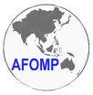  宙  時  魂 | Asia-Oceania Federation of Organization  for Medical Physics  www.afomp.org

2008 AFOMP Annual Council Meeting

Minutes of Meeting

Date : October 31 (Fri), 2008
Time : 12:30 – 15:30
Venue : B2, CHORAY Hospital, Ho Chi Minh city, Vietnam

AFOMP Annual Council Meeting, 2008, Ho Chi Minh city, Vietnam

Minutes of Meeting

Venue : B2, CHORAY Hospital, Ho Chi Minh city, Vietnam
Time : 12:30-15:30, October 31, 2008
Present :
Kiyonari Inamura, President (Voting Delegate of JSMP, Japan)
Barry Allen, IOMP President, Past President (Voting Delegate of ACPSEM, Australia)
Kwan-Hoong Ng, Vice President (Voting Delegate of Malaysia)
Tae-Suk Suh, Secretary General (Voting Delegate of KSMP, Korea)
Anchali Krisanachinda, Treasurer (Voting Delegate of Thailand)
Kin-Yin Cheung, ETC Chair (Voting Delegate of KSMP, Hong-Kong)
Tatsuaki Kanai, Voting Delegate of Japan
Kodera, Voting Delegate of Japan on behalf of Hidetoshi Saitoh
Kanematsu, Voting Delegate of Japan on behalf of Akifumi Fukumura
Yimin Hu, Voting Delegate of China
A. P. Peralta, Voting Delegate of Republic of the Philippines
Ho-Ling Anthony Liu, Voting Delegate of Republic of China, Taiwan
James Lee, Voting Delegate of Singapore
Hee Joong Kim, Korea, Voting Delegate of KSMP, Korea

N. Suntharalingam, USA
Jake Van Dyk, Canada
Donald McLean, Australia
Frances CM Lopez, Republic of the Philippines
Jeong-Hoon Park, Webmaster of AFOMP, Korea

- Agenda: The meeting agenda is given in Appendix 1, and approved.
- Award ceremony to Dr. Kin-Yin Cheung was performed for his contribution to AFOMP.
- President’s Report: Kiyonari Inamura (Japan) presented the President’s report. Agreed by A. P. Peralta (Philippines) and seconded by B Allen (Australia).
- President proposed to circulate and vote important issues by e-mail and website. The first agenda is AFOMP dues and it has to be determined within next two weeks.
- Treasurer’s Report: A Krisanachinda (Thailand) presented the Treasurer’s report and the report was endorsed by Council Members. Agreed by T. S. Suh (Korea) and seconded by A. P. Peralta (Philippines).
- Secretary General’s Report: T.S. Suh (Korea) presented the Secretary General’s report. Agreed by K Inamura (Japan) and seconded by B Allen (Australia).
- Education and Training Committee Report: K Y Cheung (Hong Kong) presented ETC report. Agreed by K Inamura (Japan) and seconded by T. S. Suh (Korea).
- Dr. Cheung proposed the possibility of establishing an international certification.
- Dr. Suntha advised to differentiate the term “license” and “certificate”.
- Dr. Van Dyk suggested to discuss it in the international society level.
- Professional Development Committee Report: K H Ng (Malaysia) presented PDC report. Agreed by K Inamura (Japan) and seconded by B Allen (Australia).
- A survey on the status of medical physics in Asia and Oceania will be circulated by PDC members and it will be published as a final report.
- Science Committee Report: SC Report was not presented due to his absence in council meeting. President Inamura decided to contact Dr. Bao personally.
- Commercial Fund Committee Report: Barry Allen (Australia) presented the CFC Report. The number of AFOMP corporate membership became seven in this year. An invoice of corporate membership for annual revision will be noticed to current members by Treasurer. Agreed by K Inamura (Japan) and seconded by A. P. Peralta (Philippines).
- Chiang Mai, Thailand was determined as the host city of 9th AOCMP and Taipei City, Taiwan was determined as the host city of 10th AOCMP. It was endorsed by AFOMP members and Secretary General will send decision letters to each hosting society and lose letter to Bangladeshi.
- Regarding the votes on the AFOMP dues, Malaysia, Australia and Philippines delegates proposed to give their vote after the congress to fulfill the quorum. Agreed by K Inamura (Japan) and seconded by T. S. Suh (Korea).
- Information on the ICSU grant program will be announced and circulated by e-mail and website. Agreed by K Inamura (Japan) and seconded by T. S. Suh (Korea).
- K Inamura proposed to host AOCMP 2011 in conjunction with 6th JKMP meeting and to submit an EOI for congress. The deadline of EOI for AOCMP 2011 was set to two month before next council meeting in Thailand. Agreed by T. S. Suh (Korea) and second by B Allen (Australia).
- AOB
- Taiwan delegate gave an explanation of the EOI of AOCMP 2010. AFOMP council members requested to have cooperation with Taiwan. Some political issues such as names of society was requested to be settled between CSMP and CSMPT for the successful congress.

This meeting was adjourned at 15:30 pm
- Agenda

- Attendance
- Minutes of the 2007 Council Meeting

- President's report
- Treasurer's report
- Secretary General's report
- Report by Chair: Education & Training Committee
- Report by Chair: Professional Development Committee
- Report by Chair: Science Committee
- Report by Chair: Commercial Fund Committee
- 9th and 10th AOCMP
- AFOMP dues
- ICSU Grants Program 2009
- AOCMP 2011 with 6th JKMP
- AOB
- Award to Dr. KY Cheung
[ Appendix 1]
President’s Report at 8th AOCMP

Kiyonari Inamura, AFOMP President
October 27, 2008

This is the 2nd report for me as AFOMP President. Everything is still on the way to be completed, but members of AFOMP EXCOM discussed and tried to solve problems with enthusiasm. We have paid attention to establishment of constant financial basis, such as AFOMP dues collection and AFOMP Corporate Membership. We had difficult experiences, but we have had several contracts of Corporate Membership. The problem of AFOMP dues is now being solved.

1. AFOMP related events experienced.
7th AOCMP was held by our colleague Professor Yi Min Hu in Huangshan from 23rd to 27th, August, 2007 in conjunction with Annual Meeting of Chinese Society of Medical Physics of which President is Professor Yi Min Hu.

Key members of AFOMP attended AFOMP to 25th Annual Meeting of ACMP (American College of Medical Physics) held in Seattle on May 3-6, 2008. They presented five papers and discussed key issues at the Symposium titled “International Medical Physicists Symposium: Certification of Experienced Clinical Medical Physicists - an International Cooperative Effort”. Our AFOMP Secretary General: Professor Tae Suk Suh served as the moderator. That was our first activity by which AFOMP could make appearance in an international theater. We collected the latest information on maintenance of certification and work value of medical physicist in USA that would be reflected to our future activities of AFOMP.

5th Korea-Japan Joint Meeting on Medical Physics was held in Jeju, Korea, on September 10-12, 2008, under the presidency of KSMP president Dr.Kwon, Soo-Il and JSMP president Dr. Tatsuaki Kanai. Even though it was rather local meeting, AFOMP President could explain role of AFOMP at the Symposium on Education and Training of Medical Physics. Also we discussed possibility of integration of domestic meetings such as K-J meeting into future AFOMP meetings.

We are now holding 8th AOCMP and 6th SEAFOMP in Cho Ray Hospital in Ho Chin Minh City on October 30-31, 2008 under the Presidency of Prof. Nguyen Trounng Son MD. PhD, Director of Cho Ray Hospital. We would like to express sincere gratitude to Domestic Organizing Committee Member who has made every effort to hold successful meeting. Pre-congress training course on October 29th and post-congress workshop are being held. These are first training events under the name of AFOMP

I am very pleased to congratulate on foundation of Vietnam Association for Medical Physics (VAMP). The first meeting of VAMP is being held on October 29th, 2008.

2. Other AFOMP related activites
One of official journals of AFOMP, BIIJ (Biomedical Imaging and Intervention Journal) published a paper on the survey result of present situation of medical physics in AFOMP area. ¹ That is most valuable report after three reports of the like in the past we carried out. Outline of the report is: (1) High workload of physicists with more than 500 patients per year per physicist. (2) Less than one ROMP (radiation oncology medical physicists) per two oncologists in average (3) One megavoltage treatment unit per medical physicist (4) A structured clinical training program is necessary. (5) The number of patients per physicist varies more significantly (250 to 800). (6) AFOMP has an important role to play by defining professional responsibilities and educational standard and by bringing physicists together and organizing conferences and workshops.

We had a progress of our AFOMP activities based on financial support from Corporate Members and grants from IOMP. The first education and training courses/workshops on topics on image quality assurance are being held in Ho Chin Minh city on October 29th 2008, the day before 8th AOCMP opens. This is the first training course under the name of AFOMP.

Also we have been making another effort of education and training, since AFOMP Subcommittee titled "Subcommittee for the support of an RCA project on Strengthening Medical Physics” was organized in 2002, and AFOMP and IAEA agreed on the cooperation/joint work. Items of cooperation are: (1) To review, examine and endorse Tec Doc (technical documents) published by IAEA, (2) To share complementary roles for the IAEA and AFOMP each other, (3) Key roles for IAEA are: (ⅰ) Targeting global levelled training tools based on structured program. (ⅱ) To train the trainers. (ⅲ) To develop tools and portfolios for completion of core competencies. (4) Key roles for AFOMP are: (ⅰ) To concentrate at the local level with special emphasis on provincial sites, (ⅱ) To train the trainees using equipment that they have, (ⅲ) To increase the number of trainees and (ⅳ) To work from the bottom up.

Implementation guide and application form of RCA Training Program were sent to member countries. Organization of National Responsible Organization was recommended. The deadline is set on the end of 2008.

REFERENCE:
1. T Kron, KY Cheung, J Dai, et al. Medical physics aspects of cancer care in the Asia Pacific region Biomed Imaging Interv J 2008; 4(3):e33
[ Appendix 2]
8th AOCMP
TREASURER’S REPORT
Item Description | (A) Expenditure | (B) Income
Accounting activity | 16,472* | 21,975**
Balance | 5,503
Fund brought forward from Sep 2007 | US$ 2,660
Balance carried forward to October 2008 | US$ 8,163
(September 2007 –October 2008)

*Travel Expense to Vietnam 1,075
*Benh Vien Cho Ray (Booth) 1,200
*Plaque 240
*Travel Awards (500x4) 2,000
*Student’s Award (200x3) 600
*Post Congress Expense 11,357 16,472

**Corporate Member Fees & 8th AOCMP

Gold-Best Theratronic 5,000
UNFORS 3,000
Silver -Elekta, Toshiba, 3,000
Bronze –SCJ, Tomotherapy 1,000
IOMP 5,000

Panacea 4,975 21,975

Anchali Krisanachinda
Treasurer
30 October 2008
[ Appendix 3]
Secretary General’s report

1. AFOMP Newsletter Publication
The first issue of AFOMP Newsletter was published in December 2007. Dr. Tae-Suk Suh was chosen as an editor of AFOMP Newsletter at AFOMP Council Meeting in 2007. (Annex 1. First Issue of AFOMP Newsletter)

2. Report in 7th AOCMP at Huangshan, China
The 7th AOCMP was held in the beautiful ancient city of Huangshan, China during 23-27 August 2007. The meeting was held in conjunction with 13th Annual Physics meeting of the Chinese Society of Medical Physics (CSMP) (Annex 2. The Congress Report in AFOMP Newsletter first issue)

3. Report of Other Regional Meeting
(1) 2007 UNDP KFDA Workshop
KFDA held an “International Workshop on Current Status of Radiotherapy and It’s quality Assurances” on September, 2007 in Seoul Korea. 16 experts form Asia-Oceania countries (China, Singapore, Japan, Australia, Hong Kong) provided their presentations. (Annex 3. Report of KFDA-UNDP Project in AFOMP Newsletter)

(2) The 5th SEACOMP
The fifth SEACOMP was held in Manila on 21-23 November 2007. It was organized by the Philippines Organization of medical Physics (POMP) in association with SEAFOMP and AFOMP. It was co-sponsored by the IOMP. (Annex 4. Report of 5th SEACOMP in AFOMP Newsletter)

(3) International Medical Physicists Symposium in ACMP
International medical Physicists Symposium was held under the theme of “Certification of experienced clinical medical physicists – an international cooperative effort” at ACMP in Seattle, USA on May 6, 2008. Dr. Raymond Wu, Vice-President of ACMP was making a special effort to organize this international symposium and attract medical physicists from Asia-Oceania, as well as other parts of world, to the 2008 meeting. (Annex 5. Report of ACMP )

(4) The 5th Korea-Japan Joint Symposium on Medical Physics
The 5th Korea-Japan Joint Meeting on Medical Physics (The 5th KJMMP) was held during 10-12 September, 2008 in Jeju Hanwha Resort in Jeju, Korea. It was held in conjunction with the 37th Meeting of Korean Society of Medical Physics (KSMP) and the 96th Meeting of Japan Society of Medical Physics (JSMP). (Annex 6. Congress report of 5th KJMP)

4. Announcement of Meeting
(1) The 8th AOCMP and 6th SEACOMP
The 8th AOCMP and 6th SEACOMP will be held in Ho Chi Minh city, Vietnam with the theme of "Nurturing Collaborations in Medical Physics”.
• Training course: October 28th to 29th, 2008
• AOCMP & SEACOMP: October 30th to 31st, 2008
• Palliative Radiotherapy Workshop for Developing Countries by Convener Prof. Barry J Allen: November 1st, 2008
• IAEA Training course: November 3rd to 7th, 2008

(2) ICMPRPR-2k9
International Conference on Medical Physics, Radiation Protection & Radiobiology (ICMPRPR-2K9) will be held in SMS Medical College & Hospital, Jaipur, India in 11~13, February 2009.

(3) ISRS 2009
ISRS 2009, 9th Biennial Congress and Exhibition of the International Stereotactic Radiosurgery Society, will be held in Seoul, Korea in 7~11, June 2009.

5. AFOMP dues vote
The e-mail vote on AFOMP dues were circulated by the end of August and extended to the new deadline of 20th October. Total seven countries out of seventeen member countries sent responses and this number did not satisfy the quorum required for e-mail vote.
But it is not clear all the delegates received voting e-mail and expressed their opinion since many of delegate information are out of dated. It needs to be considered restarting the vote with up-to-date delegate’s contact information.
To improve e-mail vote procedure and make it clear, online vote system should be built on AFOMP homepage and included in website renewal plan.

6. Call for EOI 2009, 2010
Thailand submitted EOI for 9th AOCMP and Bangladeshi and Taiwan submitted EOIs for 10th AOCMP. Their EOIs will be discussed in AFOMP ExCom/Council meeting.

7. Update of delegates of AFOMP
The delegate lists on AFOMP homepage and mailing list are out of dated. So a survey on new national ExCom and AFOMP delegates was circulated on October, 2008. About 80% of delegate’s information were collected and confirmed by national societies. The delegates list will be updated on AFOMP website and it will be shared to ExCom and council members. But to maintain these information up-to-dated, all member countries should inform Secretary General and webmaster about their changes.

8. AFOMP homepage
(1) Webmaster
The AFOMP homepage is managed by Mr. Jeong-Hoon Park and Mr. Seungjong Oh of Catholic University of Korea. And the annual maintenance fee of 400USD per year is contributed by Dr. Tae-Suk Suh of Catholic University of Korea from 2005. However, the maintenance fee needs to be paid officially from AFOMP budget.

(2) Contents update
As the number of corporate members increased, the sponsors section moved upper space. Currently, total five sponsor logos and website links are available and the space needs to be expanded. And the PDC and ETC members and information was updated by the request of each committee chairs.

(3) Homepage upgrade
The current homepage is built in 2005 and the update was progressed partially. The whole revision is strongly required to implement new information and features and increase the convenience of management. It is scheduled to start on the end of 2008 and enthusiastic support from ExCom and council members are necessary. Hopefully, financial support for initial cost is expected to make professional homepage.

Submitted to AFOMP EXCOM & Council Meetings, 2008
Annex 1. First Issue of AFOMP Newsletter
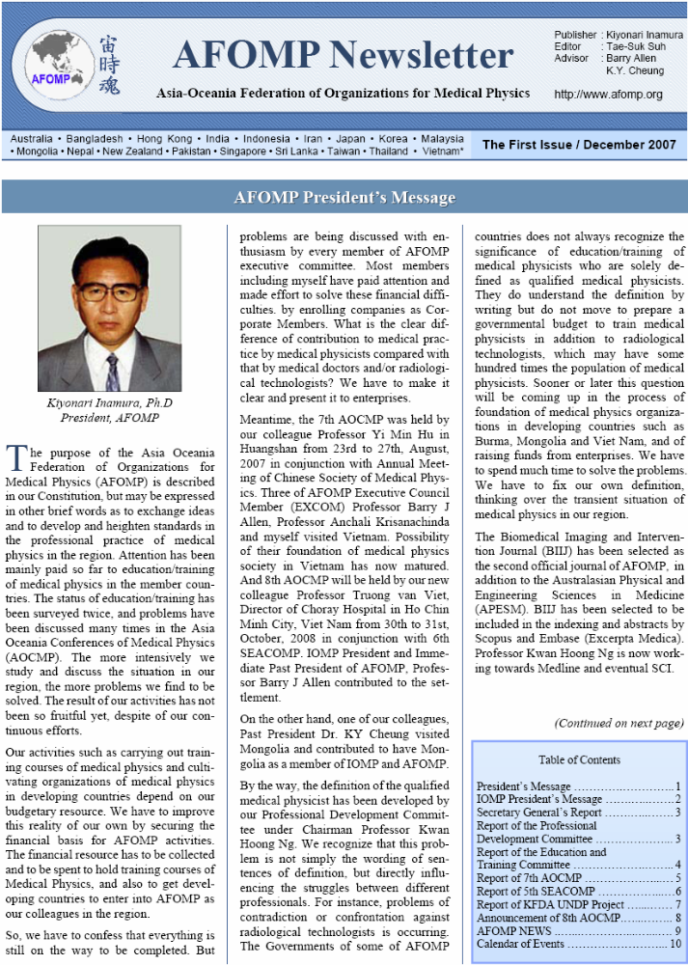
Annex 2. The Congress Report in AFOMP Newsletter first issue
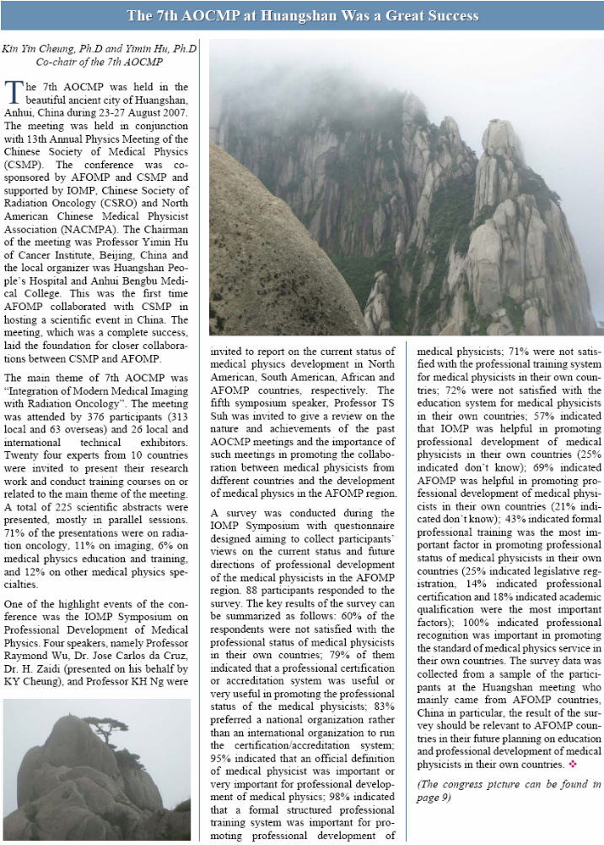 Annex 3. Report of KFDA-UNDP Project in AFOMP Newsletter
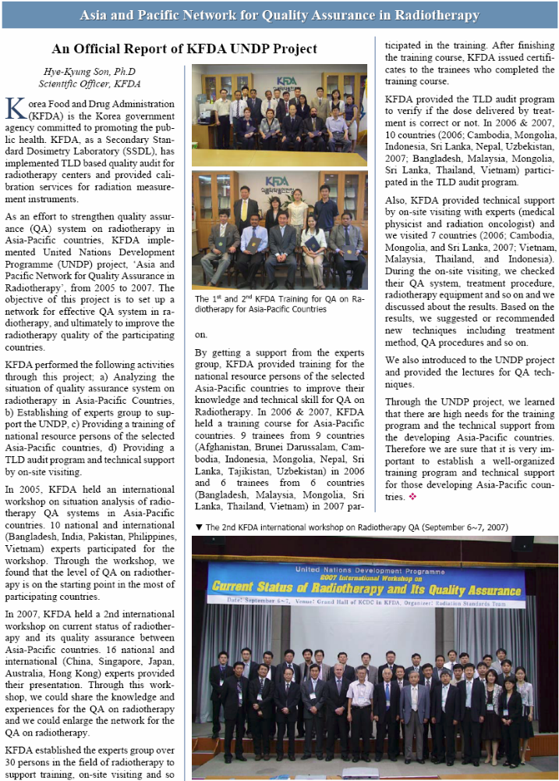 Annex 4. Report of 5th SEACOMP in AFOMP Newsletter
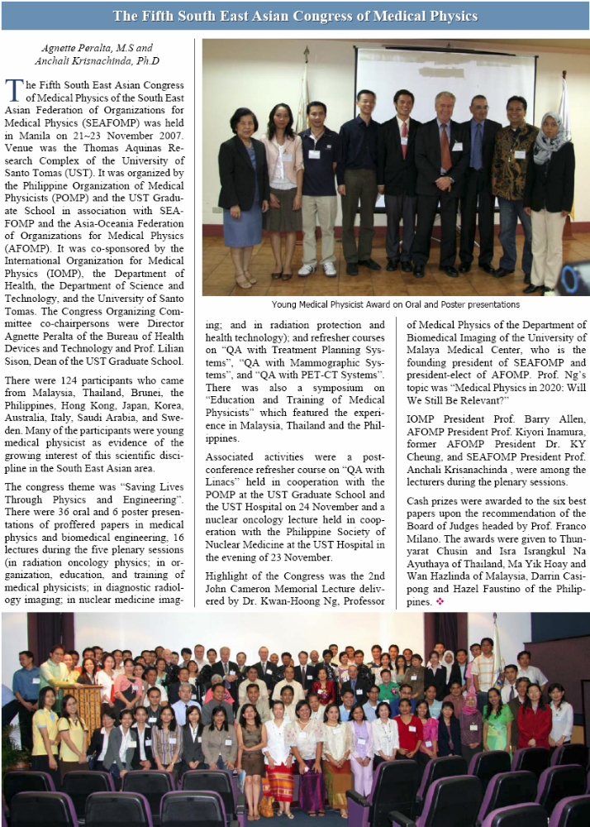 Annex 5. Report of ACMP

This international symposium focused needs of certification and learning more about how to qualify a well trained medical physicist. This symposium provided a forum to discuss topics of common interest. This symposium was chaired by Dr. Tae-Suk Suh of The Catholic university of Korea and Maria-Ester Brandan of Univesidad Nacional Autonoma, Mexico. Dr. T.S Suh (Korea), Dr. M Brandan (Mexico), Dr. A. Krisanchinda (Thailand), Dr. Hu Yimin (China), Dr. T Chang (Twain), Dr. K Inamura (Japan), and Dr. V Gonzalez (Mexico) were invited to report on the status and experience of their countries or regions including Asia and Latin America. This symposium was more enriched by the join of three key panelists: Dr. W. Hendee, Dr. G. Clarke, and G Ibott.
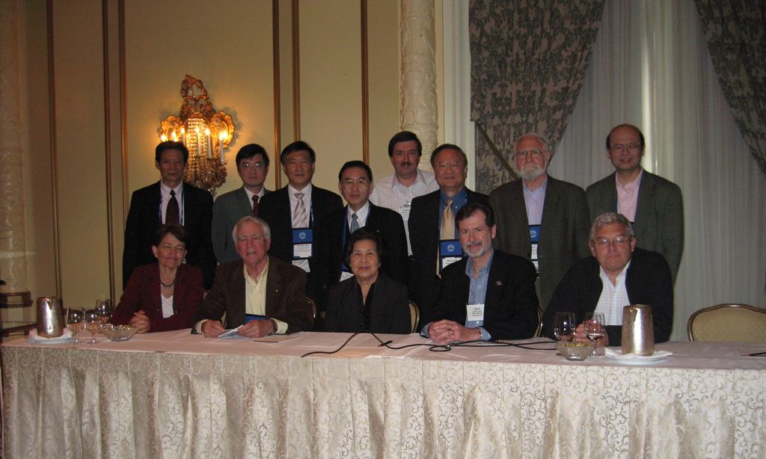
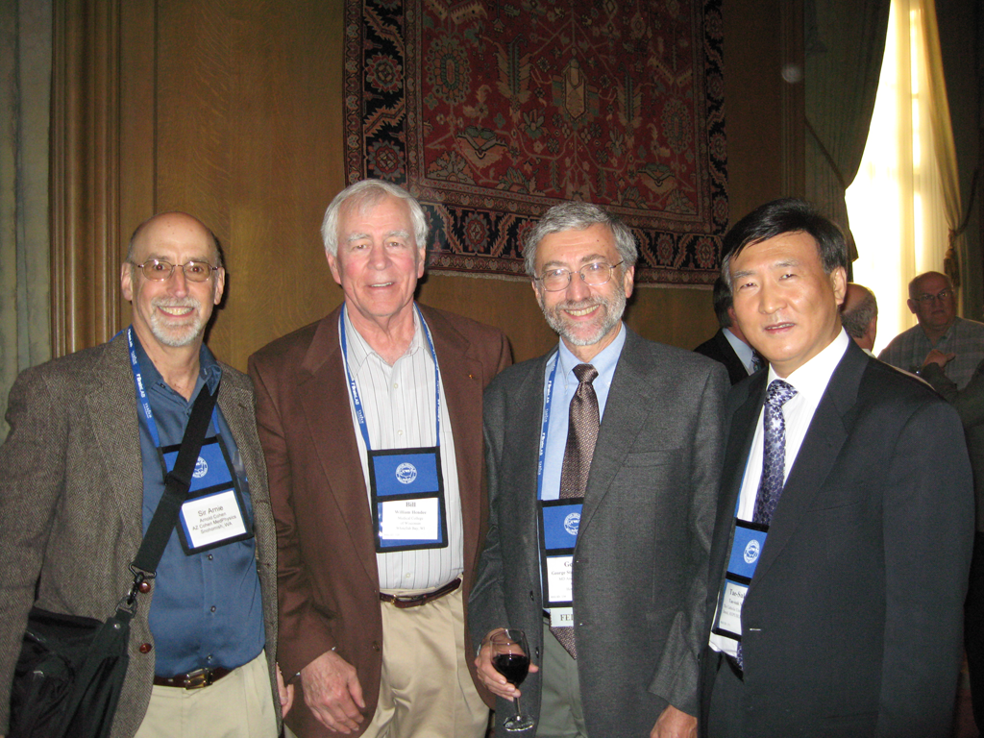
Annex 6. Congress report of 5th KJMP

The 5th Korea-Japan Joint Meeting on Medical Physics (The 5th KJMMP) was held during 10-12 September, 2008 in Jeju Hanwha Resort in Jeju, Korea. It was held in conjunction with the 37th Meeting of Korean Society of Medical Physics (KSMP) and the 96th Meeting of Japan Society of Medical Physics (JSMP). This Joint Meeting has been already held 4 times (two in Korea, two in Japan). The past four Joint Meetings were quite successful and have made an important role to promote research activities in medical physics, while offering a great opportunity of cultural exchange between two societies. The theme of 5th KJMP was “New Horizon of Medical Physics”. The meeting extended our visions on the medical physics by introducing new paradigm of future trend of medical physics which utilize interdisciplinary approaches such as image-guided therapy, and state of art imaging technique. This is truly reflected by the plenary session, and other symposiums.
Professor William Hendee from the University of Wisconsin, USA gave an outstanding plenary speech on “Entrepreneurship in Medical Physics”. Another Plenary speaker Dr. Tatsuaki Kanai from NIRS, Japan also gave a nice presentation on “Progress in Carbon Radiotherapy”. There were three excellent symposiums: “Advanced Technology in Radiation Therapy”, “The State of Art Molecular Imaging Technology”, and “Education and Training of Medical Physics”. Two other leading scientists invited from USA, Dr. Daniel Low from Washington University and Dr. Jason Sohn from Case Western University also covered new idea on IGRT and adaptive RT in their lectures. The symposium on “Education and training of Medical Physics” was an important event of 5th KJMP, and was moderated by Dr. William Hendee with five key panelists from Korea and Japan.
The conference was attended by 205 participants. Abstracts considered within the scientific program were 68 oral presentations, 61 posters. There were 13 invited oral presentations in plenary or symposium. The young investigator’s awards were provided to four young scientists from Korea and Japan through the competition in “Young Investigator’s Presentation Session”
A series of social activities were arranged with the Welcome Reception held on a beautiful garden locating in the middle of Halla Mountain. Some tours were arranged to allow attendees to see the beautiful scenery and history in Jeju.
5th KJMP provided a great opportunity for the attendees to update themselves on the current trends in various fields of medical physics by exchanging scientific and technological information as well as strengthening friendship between Korean and Japanese medical physicists. In addition to the academic aspects of the Congress, Jeju offers unique experiences for all the members with its rich heritages and tradition lifestyle.
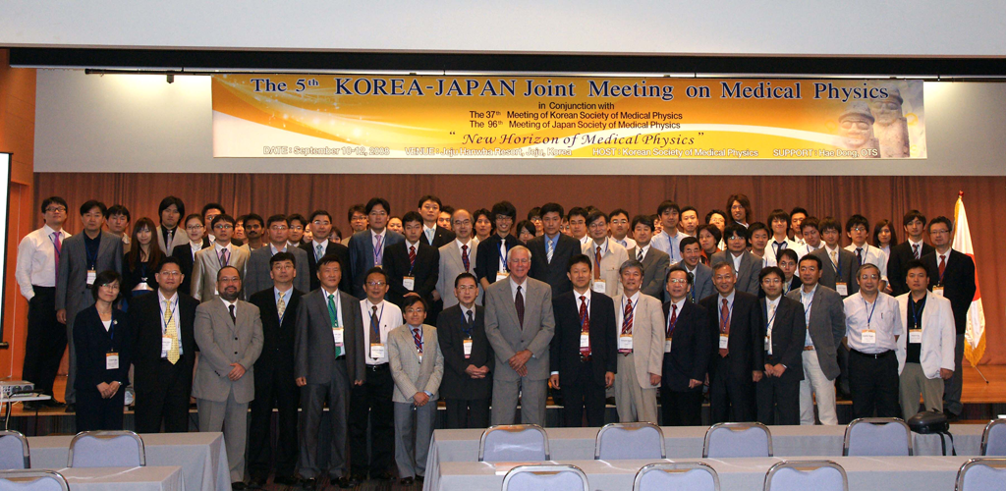
[ Appendix 4]

Report of Education and Training Committee

Submitted to AFOMP EXCOM & Council, 30 October 2008
By KY Cheung, Chairman of ETC

Past Activities of ETC during the period August 2007 to September 2008 can be summarizes as follows:
- Members of ETC have been updated as follow:
Professor Arun Chougule, India
Professor Soejoko Djarwani, Indonesia
Professor John Drew, Australia
Professor Yimin Hu, China
Professor Kiyonari Inamura, Japan
Professor Anchali Krisanachinda, Thailand
Professor Chung-Chi Lee, Taiwan
Dr. Rena Lee, Korea
Dr. Donald Mclean, IAEA
Professor Kwan Hoong Ng, Malaysia
Dr. Madan M. Rehani, IAEA
Professor Shinichi Wada, Japan

- The Committee has review and endorsed the following IAEA documents:
  - Quality assurance in screen-film mammography
  - Quality assurance in digital mammography

- Supported in organizing the International Medical Physicist Symposium on Certification of Experienced Clinical Medical Physicists – An International Cooperative Effort held as part of the ACMP Meeting in May 2008.

- Set up the 8th AOCMP Travel Award Committee to design and implement a mechanism for granting travel support to young AFOMP medical physicist to attend 8th AOCMP in Vietnam.

- Contributed in the planning and organizing of the Symposium on Professional Training of Medical Physicists in AFOMP during 8th AOCMP & 6th SEACOMP held in Ho Chi Minh City, Vietnam.

Looking Forward
- To explore the possibility of establishing an international certification body for accreditation of medical physicists in AFOMP for the purpose of improve standard of practice. Initial actions are being initiated to strengthen the partnership with AAPM, ABR and ACMP and IOMP on this issue, including the setting up of a meeting during WC2009.

[ Appendix 5]

Report of the AFOMP Professional Development Committee (2007 - 2008)

- The PDC has been drafting the “AFOMP Policy Statement No.2: Recommended Clinical Radiation Oncology Medical Physicist Staffing Levels in AFOMP Countries”. The task is headed by Howell Round and Khoon Tay Yak. KH Ng will present the progress report on behalf of the PDC during the 8th AOCMP and 6th SEACOMP, Ho Chi Minh City, Vietnam, Oct 30-31, 2008. We target to have the final draft ready for circulation by mid-2009.

- The PDC has also collaborated with Tomas Kron and the Biomedical Imaging and Intervention Journal www.biij.org resulting in the publication of a review paper “Medical physics aspects of cancer care in the Asia Pacific region” - T Kron, KY Cheung, J Dai, P Ravindran, D Soejoko, K Inamura, JY Song, L Bold, R Srivastava, L Rodriguez, TJ Wong, A Kumara, CC Lee, A Krisanachinda, XC Nguyen, KH Ng. Biomed Imaging Interv J 2008; 4(3):e33.

This represents a significant landmark in regional cooperation and for the first time we have concrete published data on the status of medical physics in Asia and Oceania.

The chairman would like to thank all the members for their cooperation and contribution towards the success of the PDC.

AFOMP PDC members 2007-08

Prof. Kwan-Hoong Ng MYS dwlng@tm.net.my (chairman)
Dr. Kin-yin Cheung HKG kycheung@ha.org.hk
Dr. Youngyih Han KOR youngyih@skku.edu
Prof. Yaoxiong Huang CHN tyxhuang@jnu.edu.cn
Dr. Nobuyuki Kanematsu JPN nkanemat@nirs.go.jp
Dr. Hee-Joung Kim KOR hjkim@yumc.yonsei.ac.kr
Assoc. Prof. Anchali Krisananchida THA kanchali@yahoo.com
Assoc. Prof. Ho-Ling Anthony Liu TWA hlaliu@mail.cgu.edu.tw
Dr. Howell Round NZL h.round@waikato.ac.nz
Mr. Yak Khoon Tay SGP Yak_Koon_Tay@gleneagles.com.sg

KH Ng
Chairman
AFOMP Professional Development Committee
Oct 2008

Abstract for 2008 AOCMP Ho Chi Minh City, Vietnam

Progress of AFOMP Policy Statement No. 2 “Recommended Clinical Radiation Oncology Medical Physicist Staffing Levels in AFOMP Countries”

Howell Round¹, Yak Koon Tay², Kwan-Hoong Ng³
¹Departmentof Physics and Electrical Engineering, University of Waikato, New Zealand
² Cancer Centre, Gleneagles Hospital, Singapore
³Department of Biomedical Imaging and Medical Physics Unit, University of Malaya, Kuala Lumpur, Malaysia

The AFOMP Professional Development Committee (PDC) has been working on a number of important tasks. Among them are drafting of a set of policy statements which give recommendations and guidelines on issues such as the definitions on the roles and responsibility of medical physicists, their professional and quality standards, and the standard and structure of education and training of medical physicists. This policy statement, which is the second of a series of documents outlines the official views of AFOMP on recommended clinical medical physicist staffing levels in radiation oncology departments. It aims to serve as a guideline or reference document for AFOMP organizations.

The philosophy and rationale in defining suitable radiation oncology medical physicist staffing levels will be explained.
Proposed recommended staffing guidelines include:
- Every radiation oncology department must employ at least one qualified clinical radiation oncology medical physicist as specified in AFOMP Policy Number 1.
- The number of qualified medical physicists in a department must generally exceed the number of unqualified clinical radiation oncology medical physicist being trained within the department.
- Time must be provided for continuing professional development, teaching and training.
- Senior physicists must be provided with sufficient time to train and mentor trainee/junior/registrar/resident physicists.
Currently activity is focused on developing EFT-based guideline for departments.

-------------------------------------------------------------------------------------------------------------------------------

Medical physics aspects of cancer care in the Asia Pacific region

- T Kron, KY Cheung, J Dai, P Ravindran, D Soejoko, K Inamura, JY Song, L Bold, R Srivastava, L Rodriguez, TJ Wong, A Kumara, CC Lee, A Krisanachinda, XC Nguyen, KH Ng. Biomed Imaging Interv J 2008; 4(3):e33
Abstract
Medical physics plays an essential role in modern medicine. This is particularly evident in cancer care where medical physicists are involved in radiotherapy treatment planning and quality assurance as well as in imaging and radiation protection. Due to the large variety of tasks and interests, medical physics is often subdivided into specialties such as radiology, nuclear medicine and radiation oncology medical physics. However, even within their specialty, the role of radiation oncology medical physicists (ROMPs) is diverse and varies between different societies. Therefore, a questionnaire was sent to leading medical physicists in most countries/areas in the Asia/Pacific region to determine the education, role and status of medical physicists.

Answers were received from 17 countries/areas representing nearly 2800 radiation oncology medical physicists. There was general agreement that medical physicists should have both academic (typically at MSc level) and clinical (typically at least 2 years) training. ROMPs spent most of their time working in radiotherapy treatment planning (average 17 hours per week); however radiation protection and engineering tasks were also common. Typically, only physicists in large centres are involved in research and teaching. Most respondents thought that the workload of physicists was high, with more than 500 patients per year per physicist, less than one ROMP per two oncologists being the norm, and on average, one megavoltage treatment unit per medical physicist.
There was also a clear indication of increased complexity of technology in the region with many countries/areas reporting to have installed helical tomotherapy, IMRT (Intensity Modulated Radiation Therapy), IGRT (Image Guided Radiation Therapy), Gamma-knife and Cyber-knife units. This and the continued workload from brachytherapy will require growing expertise and numbers in the medical physics workforce. Addressing these needs will be an important challenge for the future. © 2008 Biomedical Imaging and Intervention Journal. All rights reserved.

