Standing on the Shoulders of Giants
A Continuing Medical Education (CME) Program
On the occasion of
International Day of Medical Physics (IDMP) & International Day of Radiology (IDoR)
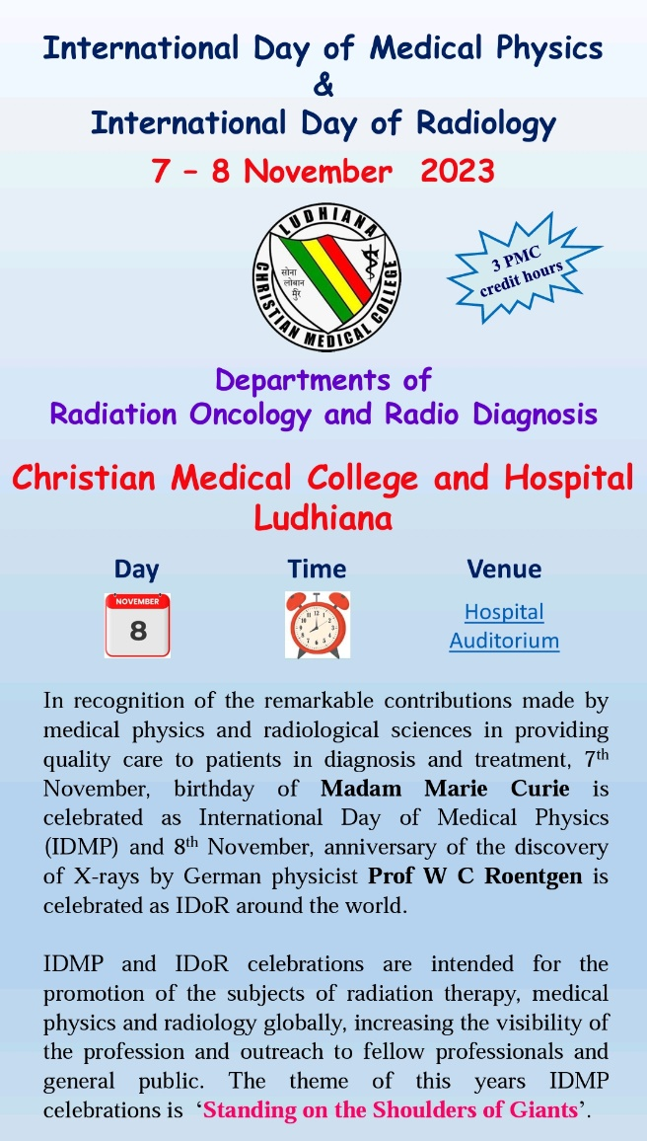
8th November 2023
On 8th November 2023, a Continuing Medical Education (CME) Program on the theme ‘Standing on the Shoulders of Giants’ was organized by the Departments of Radiation Oncology and Radio Diagnosis Christian Medical College & Hospital, Ludhiana to commemorate the International Day of Medical Physics (IDMP) and the International Day of Radiology (IDoR) 2023. This CME was accredited with 3 credit hours by the Punjab Medical Council. The CME was held in the Guy & Constable Auditorium, Christian Medical College and Hospital, Ludhiana.
Contribution of Medical Physics in healthcare is multi-dimensional and it has improved the healthcare tremendously. The recent advancements in Medical Physics may it be in Radio diagnosis, Radiotherapy, Nuclear Medicine and various fields specially using ionizing radiation has made monumental sprints. To bring over it and recognize the contribution of Medical Physics to healthcare, International Organization for Medical Physics (IOMP) has started to celebrate 7th November, the birthday of Madam Marie Curie as International Day of Medical Physics (IDMP) since 2013. The main purpose of IDMP celebrations include motivating the organization of activities that result in the promotion of the subject of medical physics globally, increasing the visibility of the profession and outreach to fellow professionals and general public. Since the 7th day of November 2013, the very first International Day of Medical Physics, where various academic and teaching institutes showcased the contributions of medical physicists to healthcare globally and continues to be celebrated annually thereafter. Discovery of X-rays on 8 November 1895 by German physicist Prof Wilhelm Roentgen has revolutionized the medical diagnosis and treatment. The anniversary of this discovery is celebrated around the world as IDoR in recognition of the remarkable contributions made by radiological imaging and radiological treatment to health care, and the role of radiation professionals in providing quality care to patients.
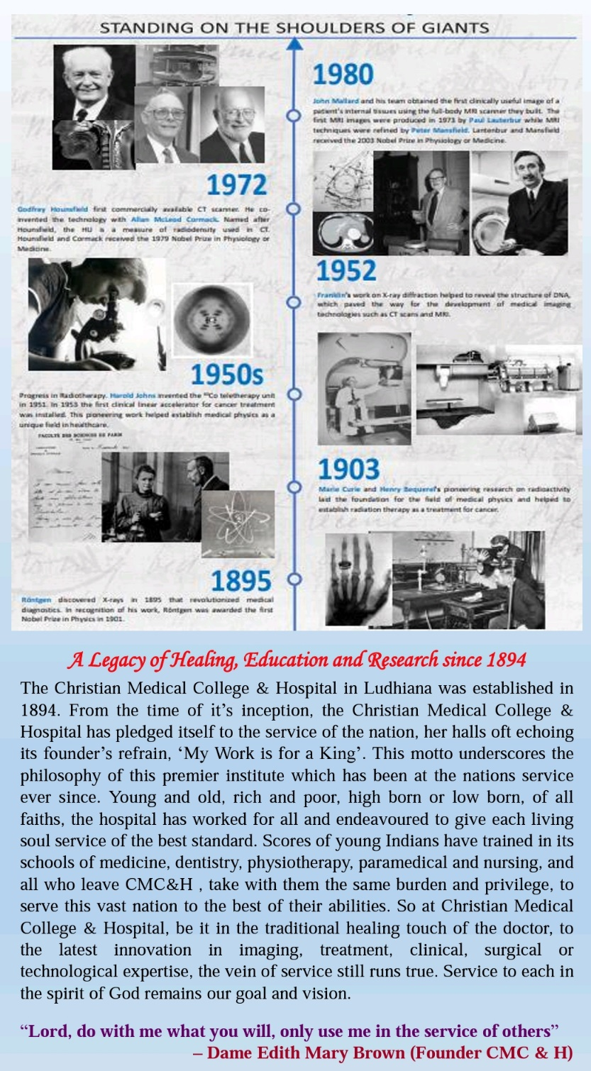
Christian Medical College and Hospital Ludhiana has been always in the forefront to avail the best diagnostic and treatment facilities to treat patients since 1894. The teaching and training program for radiotherapy technologists in CMC Ludhiana dates to early 1960’s and the MD Radiation Oncology program at the institute completed 30 years. The departments of Radiation Oncology and Radio Diagnosis collectively decided to commemorate the IDMP and IDoR 2023 and more than 260 healthcare professionals and trainees attended the CME.
The CME started with the inaugural ceremony which was graced by Dr William Bhatti, Director, CMC and Hospital, Ludhiana, Dr Jeyaraj Pandian, Principal Christian Medical College Ludhiana, Dr Allen Joseph, Medical Superintendent, CMC Hospital and Dr MK Mahajan Chief Guest and key note speaker. The inaugural program started with a prayer by Rev. Fr. Alex Peter and invocation song by the radiotherapy choir. Dr Pamela Jeyaraj, Prof and Head Department of Radiation Oncology and the Organizing Chairperson of the CME formally welcomed all the guests and delegates. Dr Harish Gambhir spoke about IDMP and IDoR and threw light on the objectives of the CME highlighting the contributions of Madame Marie Curie and Prof W C Roentgen. Dr. William Bhatti emphasized the importance of remembering the pioneers and their contributions and stated that we learn and grow in the process. Dr. Jeyaraj Pandian highlighted the importance of scientific acumen and shared insights to define and design research goals for dealing with the disease burden of the country. He also appreciated the efforts of the Department of Radiation Oncology for organizing this CME. Dr. Allen Joseph spoke on the need of keeping everyone updated with advanced treatment options and developing necessary skills and conveyed the IDMP and IDoR greetings. Prof Dr MK Mahajan a pioneer of Radiation Oncology in the region and giant in view of his services took the audience through the journey of development of Radiology and Radiation Oncology at CMCH Ludhiana. The inaugural ceremony ended with Dr. Mary Joan, Associate Professor and RSO and the Organizing Secretary of the CME extending a vote of thanks to the entire invited faculty, delegates and the team of support persons.
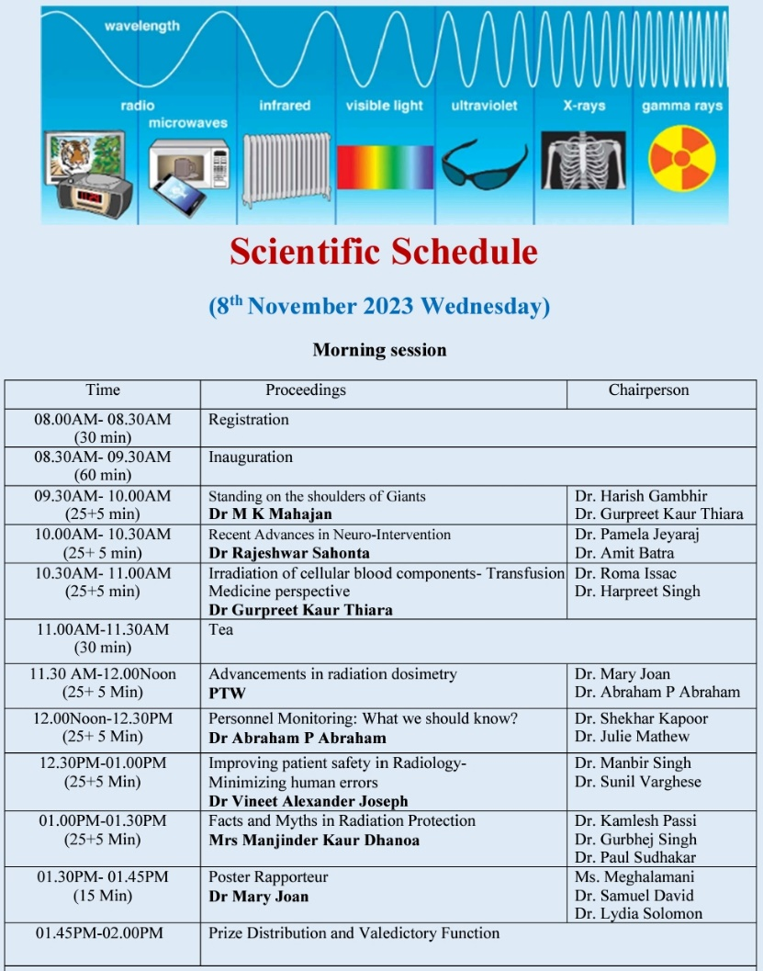
The theme of this year’s IDMP celebrations was ‘Standing on the Shoulders of Giants’ and it inspires us to continue our collective commitment to improving patient care, advancing medical technology, and enhancing the overall well-being of our communities. THE IDMP day is dedicated to raising awareness about the role of medical physicists in healthcare and their contributions to the well-being of patients. Medical physicists play a crucial role in areas such as radiation therapy, diagnostic imaging, and nuclear medicine, ensuring the safe and effective use of medical technology. The International Day of Medical Physics serves to highlight the importance of their work in improving the diagnosis and treatment of diseases and promoting the well-being of individuals worldwide. The rapidly evolving applications of physics in medicine demands new set of skills as well as outlooks to meet the challenges efficiently and successfully. This CME offered a forum for radiation professionals of various healthcare streams to come together and share invaluable experiences for improving the practice of applications of radiation in medicine. The scientific program included a key note talk by veteran radiation oncologist and former Professor and Head of Department of Radiation Oncology, CMC Ludhiana on the theme ‘Standing on the Shoulders of Giants’. He has emphasized not only the contributions of giant scientists and clinical medical physicists to the field of radiation oncology, but also reiterated the importance of the role of medical physicists in routine clinical activities of radiation oncology, academic and research work. The session was moderated by Dr Harish Gambhir, Sono-Radiologist, CMCH Ludhiana and Dr Gurpreet Kaur Thiara, Transfusion Medicine Head, CMCH Ludhiana. Following the keynote address, Dr Rajeshwar Sahonta, Associate Professor of Neurology and Interventional Neurology spoke about the ‘Recent Advances in Neuro-Interventions, moderated by Dr Pamela Jeyaraj, Radiation Oncologist and Dr Amit Batra, Interventional Radiologist.
CMCH Ludhiana has a dedicated gamma blood irradiator facility for blood and blood components and Dr Gurpreet Kaur Thiara, Head, Transfusion Medicine talked about ‘irradiation of cellular blood components: transfusion medicine perspective’ moderated by Dr Harpreet Singh, Head Radiation Oncology, Mohan Dai Oswal Cancer Hospital, Ludhiana and Dr Roma Issac, Head, Pathology, CMCL Ludhiana. Indications and contra indications for blood irradiation, when to use the irradiated blood, The talk was followed by short quiz for the participants on blood irradiation. A promotional video from PTW on advances in radiation dosimetry was displayed after the tea break moderated by Dr Mary Joan, Medical Physicist and Dr Abraham P Abraham, Radiation Oncologist.
The next talk was ‘Personal monitoring: What we should know’ by Dr Abraham P Abraham, Radiation Oncologist moderated by Dr Shekhar Kapoor, Head, Oral Medicine and Radiology, CMCH Ludhiana and Dr Julie Mathew, Christian Dental College Ludhiana. The next talk was on ‘Improving Patient Safety in Radiology- Minimizing Human Errors’, by Dr Vineet Alexander Joseph a third year PG resident in Radio Diagnosis moderated by Dr Manbir Singh, Head, Urology, CMCH Ludhiana and Dr Sunil Varghese, ENT, CMCH Ludhiana. Varying situations in Radiology in radiation safety and physical safety was discussed in the session along with practical examples from Urology and ENT. Following that the ‘Facts and Myths in Radiation Protection’ was discussed by Mrs Manjinder Kaur Dhanoa, Tutor and Senior Radiotherapy Technologist. This session was moderated by Dr Kamlesh Passi, Senior Medical Physicist, Mohan Dai Oswal Cancer Hospital, Dr Paul S John, Head, Neurosurgery, CMCH Ludhiana and Dr Gurbhej Sing, Head, Cardiology, CMCH Ludhiana. A thriving discussion followed including various practical situations and challenges in neurosurgery, cardiology and even considering patient safety and patient doses.
A poster making competition on the theme ‘Standing on the Shoulders of Giants’ was organized for the graduate students to promote awareness and to nurture all round development. An enthusiastic participation from students comprising 52 posters and 2 models upheld the spirit of the IDMP celebrations. The rapporteuring of posters was done by Dr Mary Joan. Mr Nikhil Mathew and Ms Harshpreet Kaur won the first and second prizes for model and Ms Vedika Choudhary, Ms Samreen Ansari and Ms Komal Pal won the 1st, 2nd and 3rd Prizes in poster respectively. Dr Samuel David, Associate Director, CMCH Ludhiana presented the results and awards to the winners. Following the prize distribution, the CME came to an end with a vote of thanks and the ethos of ‘Standing on the Shoulders of Giants’ strongly reverberating in all participants.

Gallery
